*translated from Malay language original article

Golden Dream Wheel Enhances the Attendance and Understanding of Students with Special Educational Needs

Intan Norzira Binti Tormudzi

Sekolah Menengah Kebangsaan Air Molek, Melaka
intannorziratormudzi@gmail.com

ABSTRACT

The Golden Dream Wheel (GDW) is a reward system or economic token used to encourage students to attend school. GDW is used to change unwanted behavior and attract students to follow the class while increasing students' understanding during the teaching and learning process. Golden Dream Wheel is a best practice that has been implemented by practitioners (teachers). Pupils will be given marks for each time they attend school and marks will also be given for each assignment made and the correct answer for the quiz given. Scores will be recorded in the GDW to be accumulated over a period of time. The marks collected will be converted into existing materials that students like such as money, stationery, food and others that are agreed by students and teachers. By using this good practice, students always focus on the learning session to enable them to earn marks that can be exchanged for rewards. This best practice aims to increase student attendance as well as student understanding in the teaching and learning process (PdPc). Through this best practice, the percentage of student attendance increases and so does students' understanding of the lessons taught. The Golden Dream Wheel produced is an added value in helping to increase the percentage of student attendance, as well as improve student understanding. It is hoped that this best practice can help special education teachers in increasing the problem of student absenteeism.

Keywords : Golden Dream wheel, Token Economy, Rewards, Student attendance Typical education
___________________________________________________________________

Introduction to Best Practices

Before the Covid 19 pandemic came about, I used the reward book system during PdPc to motivate my students to learn. Each student had a reward book to record the marks they earned. The use of reward books really helped teachers in attracting students to follow classes and attend school. Pupils would always stay focussed during PdPc to get marks for which can be exchanged for prizes. Realising the effectiveness of the reward book, there was a need to convert the reward book into GDW in a digital form when home-based learning (PdPR) sessions are carried out during the pandemic.
More attractive prizes are offered to those who attend the class as well as those who can answer questions and do the assignments given. By using this GDW, students are happier and more excited to attend PdPR classes. More and more people are attending classes during PdPr because they want to collect marks to get rewards. I will show how to use GDW in the classroom during PdPr Managing student behavior is an area that is a priority for educators because student behavior affects a learning environment. Developing both academic skills and positive behaviors is essential in achieving an effective classroom.

Therefore, it is the responsibility of an educator to produce a student who is disciplined, noble and responsible. This is in line with the National Education Philosophy, which is to produce human capital that is comprehensive from the physical, emotional, spiritual, intellectual and social aspects.

Sabilah Wahab (2006) states that there is a group of students who are labelled special or special students. These students should be entitled to the same privileges as other students but they are often seen as weak, backward or sluggish. These students actually need to be given extra attention and encouragement so that they can contribute to the country like other normal students. Abdul Ghani Abdullah and Abd. Rahman Abd Aziz (2009) stated that the way to develop leadership characteristics and students' identity so that it becomes a better value of self -control is by emphasizing the human aspect.

The humanitarian aspect can help develop human beings while training and guiding students to be more responsible without imposing coercion. Educators especially Special Education teachers need to be creative and critical in choosing the use of appropriate methods to address the behavioral problems of Special Education students which generally have a wide variety and categories. Thus, the researcher has chosen the Economic Token' at the beginning where the concept would be seen reflected in the 'the reward book' and GDW system which is felt to be appropriate to reduce the problematic behavior of the subject not like to attend or not interested in attending school.

Justification on the Implementation of Best Practices

Behavior modification is part of a large -scale intervention in social work practice. This is because human behavior is something complex, and human behavior is basically a reflection of various psychic symptoms such as knowledge, perception, interest, desire and attitude. The things that affect a person's behavior are partly located within the individual himself, which is also called internal factors, partly located outside himself or called external factors, namely environmental factors. Therefore, to change human behavior requires a variety of strategies and techniques in accordance with the approaches and theories of human behavior (Fahrudin, 1997). One of the techniques commonly used in changing human behavior based on the behaviorism approach is the Token Economy Technique.

Identified the reasons that drove the implementation of this study and innovation as follows:
1. Pupils are less interested in attending classes
2. Pupils are less interested in learning.
3. Pupils are less focused on the lessons given.

Implementation Objectives

The objectives of implementing this best practice are:

- Make learning sessions more interesting
- Be a catalyst for students to follow the learning sessions.
- Improve students' understanding of the subjects taught.
- Increase the percentage of student attendance to classes and learning sessions.

Implementation of Best Practices

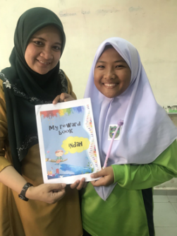  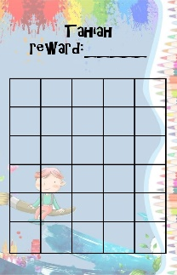 | 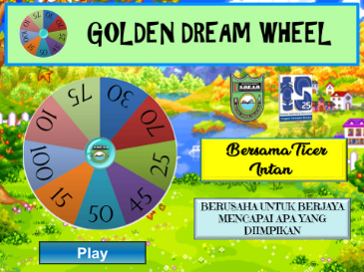  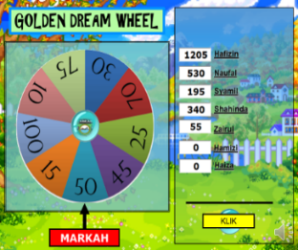
Reward Book PdPc and PdPr | GDW using Powerpoint

Step 1: Identify the Behavior
• The teacher identifies unwanted behaviour.
• The teacher makes a note about the problems faced
• Pupils are not interested in attending classes

Step 2: Intervention: How to Use GDW (Get A Score)
• Attendance for each class will be scored and will be recorded.
• Scores will be collected up to a set period of time.
• Marks will increase if students can answer questions and do assignments.
• Points will be awarded based on spins of the wheel.

Step 3: Collect and Record Scores
• The teacher will save the score every day on the GDW and will add it from time to time and tell all the students so they will get motivated to collect more marks.
• The teacher will record the marks obtained for each student.

Step 4: Delivery of Rewards
• Teacher presents a reward to the student who gets the highest score.
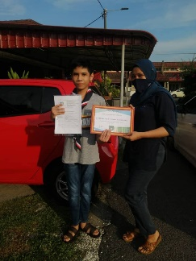
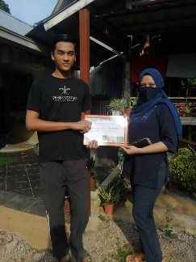
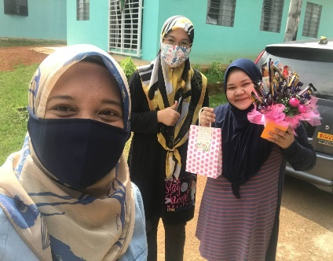
Giving rewards to students who manage to collect high marks.

Effectiveness from the Implementation of Best Practices

In this study, I have analysed the data collected in descriptive and quantitative form. Descriptive data is gathered via interview methods and observation of active student involvement while answering quiz questions. While quantitative is collected based on student attendance record document data such as dividing the number of student attendance by the number of PdPr sessions and multiplying by 100 percent (%). For the quantitative data analysis of the worksheet results, I have used the record of the number of students who submitted assignments and divided by the number of assignments that had been given. These three methods are examined with content analysis. After observing the intervention session, I filled in the items in the checklist immediately.

In addition, after interviewing students, I have produced interview transcripts to analysed the data descriptively. Interviews with students have provided an overview of the interventions that have been carefully implemented by me. I also used the data that was recorded before and after the action to analysed the quantitative data of this study aimed at evaluating and determining the number of students' attendance.

The findings of this study were done by looking at the attendance performance of students during PdPr. Table 1 shows the increase in student attendance in PdPr classes that was recorded before the intervention, during and after the intervention was introduced.

Table 1
Percentage of Student Attendance in the PdPr Session

Week | Data before |  | Intervention Data |  | Data after
 | M1 | M2 | M3 | M4 | M5 | M6
Percent (%) | 30 | 21 | 40 | 60 | 70 | 90

A checklist of student feedback on the implementation of GDW has been used. Table 2 shows the results of the students' responses. The results indicated that all the students involved were very happy and enjoyed using GDW.
Table 2
Student Feedback Checklist

NO | ITEM | YES | NO
1 | I love learning to use the Golden Dream Wheel | 7 | 0
2 | I enjoy learning and getting prizes | 7 | 0
3 | I like going to Cikgu Intan's class | 7 | 0

Conclusion and Recommendations

Based on the results of this study, it can be concluded that the approach used succeeded in changing negative attitudes to more positive ones. This proves that the Golden Dream Wheel is one of the techniques that can give impact and motivate students if it is implemented in accordance with the problem to be solved. This method must be followed up with positive reinforcement. Therefore, it is not a mistake for a teacher to use that method as a solution to a negative attitude. Apart from that, the concept of reward and punishment by Thorndike (1874-1949) and Skinner (1904-1990) has been discussed in behavioural science as a reinforcement activity in learning. In addition, there are several other things that must be implemented so that students are always enthusiastic and motivated to attend class, including:

- Conducting interesting gamification activities
- Making PdPr class interesting with simple quizzes
- Preparing interesting projects
- Always providing motivation and stimulation to students

References

Jenson, W. R., Sloane, H., & Young, R. (1988). Token economies. Applied behavior
analysis in education: A structured teaching approach. New York:

Mohd Fadli Mustafa Kamal, Mohd Hanafi Mohd Yasin & Mohd Mokhtar Tahar. 2016.
Penggunaan Teknik Peneguhan bagi Mengatasi Masalah Tingkah Laku Hiperaktif. Prosiding Seminar Antarabangsa Pendidikan Khas Rantau Asia Tenggara Siri Ke-6, 2016, hlmn. 159 165..

Purwanta, Edi. 2012. Modifikasi Perilaku Anak Berkebutuhan Khusus. Yogyakarta:
Pustaka Pelajar.

Supiah Saad (2003). Malaysian Preschool Children with ADHD in Inclusive Settings.
PhD thesis. Univercity of Warwick. Unprinted. View publication

Zalizan Mohd Jelas, 2009. Pendidikan Kanak-Kanak Berkeperluan Khas: Konsep dan
Amalan. Bangi: Penerbit Universiti Kebangsaan Malaysia

