HEARING VOICES: AN ART-BASED
PARTICIPATORY STUDY ON CHILDREN’S
EXPERIENCES OF INCLUSION AT A PRIMARY SCHOOL IN INDONESIA

Elga Andriana (eand1024@uni.sydney.edu.au)
Faculty of Education and Social Work, the University of Sydney

David Evans
Faculty of Education and Social Work, the University of Sydney

Abstract
Since the regulation of Inclusive Education for Children with Special Needs and with Talent and Giftedness was endorsed in 2009, public schools in Indonesia have incorporated various forms of inclusive practices recognising the context of each school. Following this, school level reviews have focused on readiness and effectiveness of schools in delivering inclusive practices. Nevertheless, little attention has been given to the voice of children and their perspectives on current inclusive practices in the Indonesian context. This paper aims to understand current inclusive practices in one Indonesian primary school through the lens of their students. A phenomenological inquiry was employed to examine children’s experience about the principles of inclusion and inclusive practice at their schools. We listened to individual children and groups of children, with and without special needs, as they talked about inclusion, exploring what inclusion may mean for them, and how they feel about it. Through the use of student drawings and school photo diaries, the study examined how children viewed the enactment of inclusive practices. In this particular case study, we reflect on the affordances of visual methods leading to narratives of experiences and voices of the students in special and regular classrooms within an inclusive primary school. Unique experiences of ‘inclusion day’, students being moved from special classrooms to mainstream classrooms and vice versa, students with special needs spending part of their day in the regular classrooms characterize the stories. Themes identified from students’ accounts such as friendship, meaning of being ‘regular’ and ‘special’, and participation will be explored. These themes will be contrasted with themes that have emerged from parents and teacher groups, including leadership, personal values, change, and value of academic achievement. Finally, we will discuss the experiences of the students as researchers investigating their own questions of inclusion.

Keywords: inclusion; exclusion; children’s voice

Introduction
Inclusive education has been a major education movement worldwide over the past decades; however, it is relatively new in Indonesia. The regulation of Inclusive Education for Children with Special Needs and with Talent and Giftedness (Permendiknas no.70) was endorsed in 2009. Accordingly, the principles of inclusion have only been introduced among schools in Indonesia since then. Following this, some regular public schools have been reformed into schools working towards upholding the principles of inclusion. School level reviews have examined the impact of this regulation on practices in school and on the attitudes and beliefs on members of the school community. These reviews have focused on the experience of adults using questionnaires and surveys. However, few reviews have looked at empowering children to voice their views and ideas about the inclusion movement within the Indonesian context.

It is critical to analyse whether so-called inclusive schools are really based on inclusive criteria and to analyse children’s experiences (Niholm & Alm, 2010). It is important that research scrutinise the notion of children’s experiences because of its significance in order to talk about inclusive practices, especially finding out children’s feelings of belonging, membership and acceptance. Therefore, this study is intended to investigate children’s experiences of inclusion in two primary schools in Indonesia through art-based activities.

Understanding Inclusion
The concept of inclusion can imply various meanings and can be problematic. In the arena of inclusive education, the terms of integration, mainstreaming and inclusion are often used interchangeably although they differ substantially. Integration is a term used to refer to a students’ attendance at a regular school, but they may be placed in a separate special class. In mainstreaming, students partly attend in a regular classroom, especially when they are able to follow the activity (Foreman, 2005). It can be inferred from these perspectives that it is the children with special needs who are seen as problematic and subject to be changed.

At the level of school practices, Loreman, Deppeler, and Harvey (2011) provide some examples that lead to confusion of inclusion. In particular, practices such as providing students with part time education in special schools and part time in regular schools, placing students in special or segregated classrooms in regular schools, or facilitating students with substantially different study programs in regular classroom are not inclusion.

Meanwhile, to say that inclusion means including children with disabilities fully in regular classrooms is risky too. It is one necessary character, nonetheless insufficient condition for inclusion (Nilholm & Alm, 2010). Inclusion takes a different paradigm. Inclusion means changing the practice to suit the needs of each child (Graham & Spandagou, 2011). Inclusion should be about celebrating diversity and not be about helping children with disabilities to join in on predetermined requisites and circumstances (Jones, 2005). Further, Booth and Ainscow (2011) argue that inclusion means setting out inclusive values and putting them into action. The values that are necessary for inclusive education are equality, participation, community, respect for diversity and sustainability. It critiques the narrow perspective of inclusion that limits only the participation of children with special educational needs. On the other hand, it proposes inclusion as promoting children and adults’ participation in curriculum and community.

In the complexity of efforts to describe and understand meanings of inclusion, however, Slee (2012) suggests that defining inclusion is not the real challenge.
Learning how to identify, understand and dismantle exclusion should become our focus, as it is apparent that some approaches to become inclusive, has generated exclusion. Many schools are practicing what they label as ‘inclusive’, however, on the contrary it reproduces problems they intend to solve (Black-Hawkins & Florian, 2012).

VaÌˆyrynen (2005) explored students’ experiences in two schools in Finland and South Africa to understand these experiences in relation to policies, practices and cultures of the schools. The findings showed that schools, which were working towards being inclusive, were generating exclusion as well. Teachers and staff members were not aware of exclusionary pressures that presented at schools whether they were evident or subtle ones (VaÌˆyrynen, 2005). This position may have been avoided through examining the voice of students, and how they perceived the practices being implemented.

Advocates of inclusion, therefore, call on researchers to investigate children’s voices not only to better understand inclusion, its characters and existing deficits, but more importantly looking into the insights of students to breakdown assumptions, values and meanings to improve and to advance effective inclusive practices in attaining more socially just school (Allodi, 2002; Carrington, Allen, & Osmolowski, 2007; Messiou, 2008).

Children’s Voice Through Art
The conception of ‘voice’ refers to children’s capability to speak and their right to do so (Thomson, 2008). However, Thompson further asserts that having a say is not the only meaning of voice. It involves the language as well as emotions and non-verbal ways to express views. Therefore, conducting research with attention to voice also means to listen to those that are unspoken. Practical experiences in therapy and education has developed art as a means of inquiry which allows children’s expression to be better understood and resolve difficulties that are not possible in spoken or written language (McNiff, 2011).

Kirby (1999) suggests that art-based techniques bring advantages to all children regardless of age and cognitive development. Visual art-based techniques, particularly, offer a child-centred approach allowing children, including those who have literacy or language difficulties, to describe their environments (NE-CF, 2005).

One of the art-based techniques in research using visual methods is photography. Participatory photography has become a movement and an alternative to the traditional approach where researchers take photographs and participants interpret. Photographs taken with the participatory approach can provide rich and in-depth knowledge as well as rich data set because not only that researcher can obtain what participants observe but also search out meanings in each capture (Banks, 2001; Morrow, 2001). A study in the field of disability exploring understandings of forty-six pre-school children about disability by using cameras helped researchers to understand children’s awareness of Down syndrome (Diamond, 1996).

Another visual art-based technique used with children in research is drawing. It has been shown that drawing techniques have successfully been used in research with different fields of study, such as exploring what children view as important things in their lives or to discuss topic about illness (Punch, 2002; Coates, 2004; Gibson et al., 2005). Studies using drawing with children reveal that it encourages and provides a chance for participants to be involved in meaningful way, as well as allowing researchers to understand children’s perspectives and understanding (Coad, 2007).

The School Context
The school-SDK- is located in an urban village where students mainly come from local neighbourhood with low-income families. It has two types of classes (i.e. mainstream classes from year 1-6 located at the front building of the school and special classes, also from year 1-6, at the rear building of the school). The mainstream classrooms each have around 25 students with one classroom teacher, while special classrooms has 2-6 students in each class with one special need teacher. In regard to physical environment, SDK has limited outdoor area, a small library, a sick bay, and a shared office for all school staff. The school was a regular school and one teacher initiated to gather their students who had difficulties in academic skills in one group and gave them special sessions. When the legislation of inclusive education was endorsed in 2009 they were appointed by the education department to be an inclusive school. They continued the practice of having a special group that has become larger ranging from year 1-6.

Methodology
Research design
This study was carried out over four weeks. The researcher spent the first week as a participant observer, conducting observations and interacting with all students in each year level through assisting and providing extra activities for the students. In addition, the researcher also formed informal conversations outside the classrooms as one way to address power relations between the researcher and the students.

On the second week, the researcher undertook three sessions with students to introduce them to: (1) What is research?; (2) using visual methods to research; and (3) develop your own research question. The sessions were followed by practice in using digital cameras to take photos of people, activities and things at school. The principal at SDB suggested the researcher to use the Art subject schedules in each year 1-4 class to conduct the sessions. The student participants at SDK were formed into two working groups comprising a mix of students from special classes and mainstream classes. After each practice, children had chances to view their photos with the first author and discuss how to get pictures with better qualities or more relevant to the purpose of the study.

In week three, the researcher conducted drawing sessions. Some general instructions used during initial drawing sessions such as, “Draw your happy and unhappy experiences at school”. The guiding instructions became more specific as the children raised some issues such as bullying at school.

The researcher used the final week to undertake interviews. Textural data of students’ experiences was gathered through focus group discussions and individual interviews with the students using their photos and drawings eliciting their feelings and views towards inclusive practices at their schools. Some students had extended interviews to provide deeper understanding towards their stories.

Interviews with school staff and parents were conducted to provide structural data as backgrounds to students’ experiences. Fourteen adults participated in a semi-structured interview of 60-90 minutes. Parents of students with and without special needs, senior teachers and early career teachers, special needs teachers, and the principal were interviewed separately. The questions cover topics of school context, philosophy of inclusion, vision, barriers and support, and opinion of success/failure of inclusion.

Research participants
Ten students, comprising five students from mainstream classes and five students from special classes, from year 1-5 participated in this study. The student participants at SDK were formed into two working groups comprising of a mix of students from special classes and mainstream classes in each group. The parent of one student selected to be part of the study did not give consent to join the study. The parent mentioned her concern to the researcher that this study was around inclusion and her son was a regular student in a mainstream class not a student with special needs. The parent decided not to give permission regardless of the explanation of the purpose of the study andclarification that the study will involve students with and without special needs. The student was replaced with another student who voluntary expressed his interest to be involved in the study. The other categories of participants were parents (2), classroom teachers (2), sport teacher (1), special need teacher (2) and the principal (1).

Table 1 - SDK-Student participants based on the school records

No | Initi | Gender | Category | Year
1 | Ki | M | Mental Retardation | 1
2 | Rh | M | Mental Retardation | special2
3 | Kn | M | Cerebral Palsy (wheel chair) | special4
4 | Vi | F | Visual impairment | special4
5 | Kh | F | Physical disability; Learning difficulties | special5 special
6 | Al | F | Slow leaner | class2
7 | Lf | M | Low vision | mainstrea4
8 | Ay | M | ADHD | mainstrea5
9 | Gl | F | Regular | mainstrea5
10 | Ab | M | Regular | mainstrea5
Male= 6 Female=4 Regular=2 Special Need=8 mainstrea

Data Analysis and Findings
In conducting phenomenological research, it is important to avoid analysing data by creating early categorisation, since the researcher is to seek originality of the lived experiences of participants (Bentz & Shapiro, 1998). Hence, the approach recommended by Creswell (2013) was utilised, and is shown in Figure 1.

Essence of the Phenomenon

Perso Bracketin | nal  g | Signific ant |  | Meanin | g Units | Textural Description |  | Structura l Description
- Principals, teachers and parents interviews
- School observation
Photographs, drawings
Statements
Figure 1 - Template for coding a phenomenological study

Textural Data: Students’ experiences
Friendship
The students, especially from the special classes, expressed their wish to have a friend or more friends. They want to have more friends from the mainstream classes as they only had a few friends in the special classrooms. It was observed that the students from the special classes mainly spent their playtime with peers from special classes. Kn from special class drew how he spends recess times with his friends from the same class. One of his friends had moved to a different school and he was worried that he would be lonely and that he would not have a friend to help push his wheel chair.

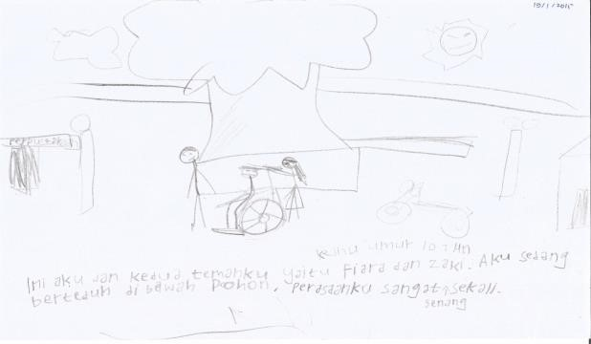
Figure 2 - “This is me and my friend F and Z. I am sitting under the big tree. I feel so happy.”
(Kn, year 4 special class)

Ab who spent year 2 and 3 in mainstream class, moved to special class in year 4, returned back to mainstream class in year 5 continues visiting the special classes during recess time as he feels that children in special classes are nicer.

“I come everyday to special class. My friend Af and Ri play funny things. What I like from regular class, I like the lesson. What I don’t like from regular class, children are naughty, they talk dirty, like to hit and kick.” (Ab, year 5 mainstream class)

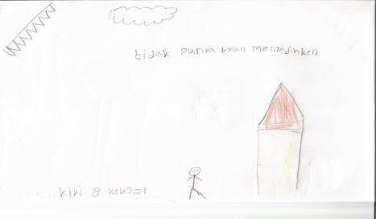
Figure 3 - “This is me, I feel sad because I don’t have friends. Children are naughty to me. I am being punched. I want to have friends from special class and mainstream class.”
(Ki, year 2 special class)

Labelling
Labels of disability and inclusion are used for many purposes in the school, for example: to call students with special needs (ABK), to call special need teachers (inclusion teacher), to call a group of parents of children with special needs (inclusion parent), to mark the school’s name that it is an inclusive school (SDK-inclusive school), and to name a weekly program “inclusion day” (group therapy). The use of a label to identify students with special needs (i.e. ‘ABK’) has strongly differentiated students with special needs from the regular students. It was also observed that regular students and teachers constantly used the labels (i.e: ‘ABK’ and ‘regular’) to differentiate students with special needs from regular students in classroom or in school events such as assembly. The students expressed their opinion on the name calling of ABK:
“It does not matter they call us ‘ABK’, it’s only a name. The fact is that we do have special needs.”
(Kn, year 4 special class)

“It is fine, it is the reality, no need to be sad. It’s only to differentiate. I personally want them not to do that, but maybe if they don’t use it they will get us all mixed up” (Kh, year 5 special class)

Being ‘special’ and ‘regular’
This type of experience is unique to students at SDK since the school has two types of classes. Some students with special needs have experiences of being moved from special classes to mainstream classes. This experience is viewed as happy experiences with reasons expressed such as more chances to learn, being smarter, study harder, bigger classroom and chances to have more friends.

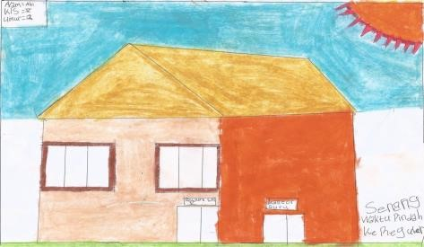

Figure 4 - “I am happy to be moved to mainstream class. I am moved to mainstream class because
I can do the lessons.”
(Ab, year 5 mainstream class)

One child who was to be moved to a mainstream class and his best friend commented:
“I feel happy that I will be moved to mainstream class. I was in mainstream class in year 3. A student from year 1 called me ‘cripple’. If it happens again it is ok. They are still little children who don’t understand what they are saying. I am worried if I will fall, there are many unlevelled stages near the mainstream class. There should be a way for wheel chair. I also worried that the lesson will be harder than in special class” (Kn, year 4 special class)

“I am glad that Kn will be moved to mainstream class. He will have more friends and get helps from many people. But it is his right if he doesn’t like mainstream class he can comeback to this class. I hope children in mainstream class accept him as he is, he is a smart boy.”
(Vi, year 4 special class)

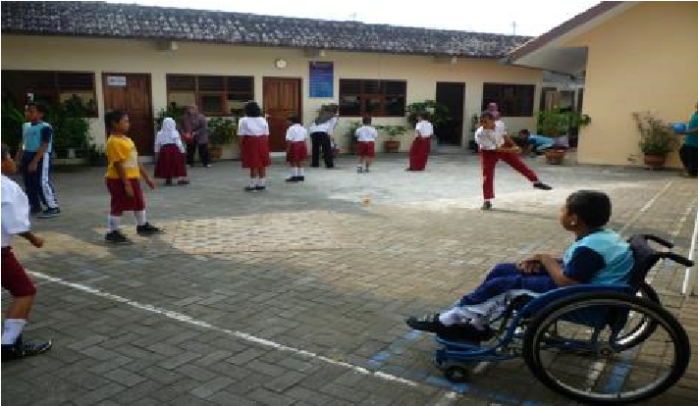
Figure 5 - “This photo shows ball play during therapy session (inclusion day). Students from mainstream class don’t need to play because so many subjects to learn to be clever.” (Rh, year 2 special class)

Participation
Students with special needs at SDK expressed happy feelings when they were told that from now they will be student on duty in the Monday school assembly. Such role in the past was only given to regular students.

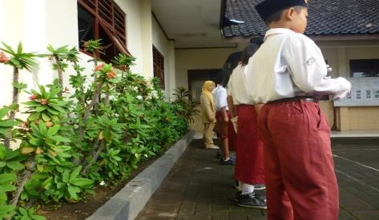
Figure 6 - “ This is Dp (a student from mainstream class). He has always been the assembly leader.
Never replaced. He is the most popular student. My heart was thumping, first time ever I became MC for the assembly.” (Kh, year 5 special class)

One child added:
“There is Ri too. The two boys never been replaced. They are from mainstream class. They are smart.” (Vi, year 4 special class)

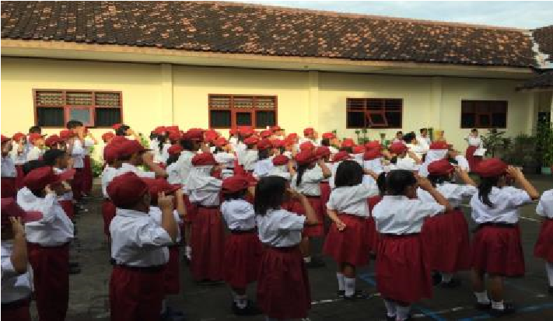
Figure 7 - “This is school assembly, all children are giving salutation to the flag. I wish I could be the student holding ‘Pancasila’ who stands next to the assembly leader.” (Kn, year 4 special class)

In regard to sports, two children with special needs (i.e., a child with low vision and a child on wheel chair) expressed their concerns that they wish to join ‘kasti’ (local cricket) or soccer. These games were often played during sport lesson but their physical condition does not allow them to do so: “I want to join kasti, I can hit the ball, but I can’t run.” (Kh, year 5 special class). “I want to play soccer but I can’t see the ball.” (Lf, year 3, a child with visual impairment in mainstream class)

On the other hand, regular students expressed their opinion that it would be good if they could join ‘inclusion day’. Inclusion day is a common practice by inclusive schools in Yogyakarta to have weekly ‘group therapy’ where children with special needs gather and do sport play or gymnastic. Regular students view this experience as having so much fun and healthy and that they wish to join the activity.

Students led inquiry of inclusion
The primary aim of this project was to give students voice to the discussion around inclusive education. Hence, the project was designed as a research with students, and students were given a role as co-researchers. The students firstly focused on inquiry into the researcher’s research questions. Following a workshop, students developed their own research questions about inclusion based on individual interests. Six questions were revealed, but only two questions being focus in this paper. Vi, a Year 4 student diagnosed with a visual impairment and slow learner in a special class, was interested in finding out what children’s understanding of ‘inclusive school’. She posed the research question: “What is inclusive school?” Vi interviewed ten students and found out four students answered, “I do not know” to her question, while six others provided their answers as below:
- School that is fun.
- School for children with special needs.
- School for children with great potentials.
- School for children who are different from others.
- Beautiful school! A school that is the same as any other regular school.
- School where everyone can learn.

Ki, a Year 2 student in a special class, and Ab, a Year 5 student in a mainstream class, were interested in finding out: “What do the students in special classes learn? Ki and Ab took photos as their method to find answer to their question. Some findings are below:

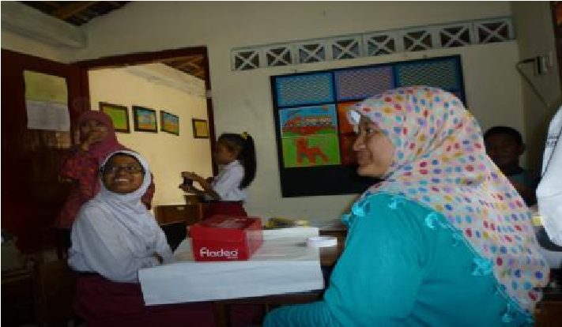
Figure 8 - “Students in special class making gift wrap. Mainstream children can learn things being learnt by inclusion children quickly. Children in special class cannot do what children in mainstream classes, it’s just too difficult for them.” (Ab, year 5 mainstream class)

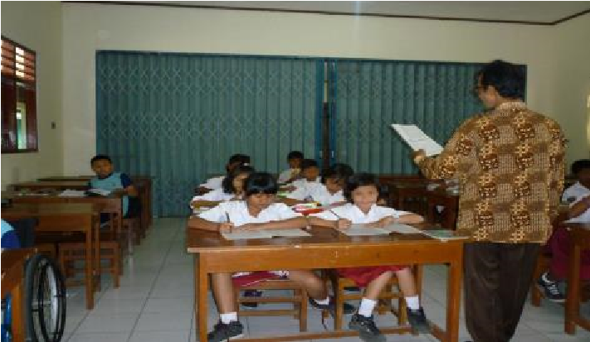
Figure 9 - “This is religion subject, in this subject, inclusion children can join mainstream class. There are K and R (inclusion children) sitting alone. It is better for regular children to sit
with inclusion children, because if inclusion children do not know something, regular child can help.” (Ab, year 5 mainstream class)

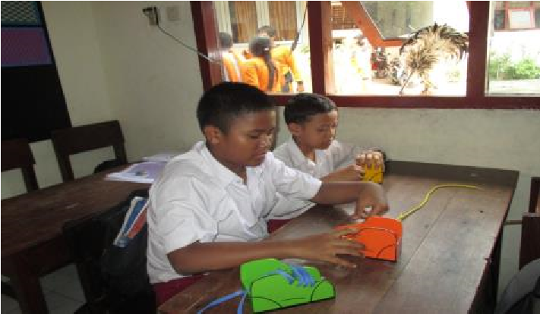
Figure 10 - “This is a good photo because children in year 5 special class are learning how to put shoelaces on. They are learning it because they can’t do it.” (Ki, year 1 special class)

The results from Vi’s inquiry provided children’s understandings of inclusion and what an inclusive school should look like. Meanwhile, Ab and Ki’ findings contributed to the theme of what it means being ‘special’ and ‘regular’.

Structural Data
Teaching method
The mainstream classroom teachers used the same curriculum for all children. The teachers also used a single method to delivering the education program to all children in their classes. In the special classes, the teachers also used the same curriculum and single method, however, the teachers were seen to provide some adjustments and give individual assistance to respond to student need.
Leadership and change
Teachers at SDK reported that the condition during the initial period of becoming an inclusive school was quite harsh. Regular teachers’ attitude towards children with special needs was very negative and students in mainstream classes didn’t show respect to the special need teachers. It was the leadership of the new principal that has changed the attitudes of the school community. The principal stated that her beliefs were rooted in personal and religious values that were the foundation to her leadership to navigate the school towards inclusion.

Acceptance
Parents of students with special needs from SDK felt that school staff and regular students accepted their children in the communities and that their children were not viewed as ‘different’ or weird. However, the parents were concerned about access to participate in excursions. One parent reported that students with physical disabilities (i.e., one with wheel chair) often being asked to stay in the library while the school has trips, such as walking around the neighbourhood.

Discussion
A significant theme to emerge from this study is of self-identity; of being ‘special’ and ‘regular’. It is shown from the findings that the students from the special classes have developed self-acceptance that they have special needs, of being known as ABK, and attached to characteristics and perceptions such as low ability, incapable and different. In contrast, students in the mainstream class are seen as having higher status with qualities such as smart, can do things, and popular.

It is important to understand what school factors influence the views of children at SDK about disability, whether it is the view of others or self. In a study investigating children’s constructions of meaning about other children, factors such as interaction between children, behaviour of the adults at the school, academic systems in the school and the school culture influenced children’s perceptions about other children with special needs (Messiou, 2008). Research shows that teacher’s practice in the classroom and actual words they use are key factors influencing children’s view of their peers with special needs. Further, not only did teachers have the key role in providing examples through their own practices, teachers have the key role to control, influence, and actively clarify labels and language being used by regular students to name their peers or misconceptions they may have about disabilities. Teachers have a role to play by modelling behaviour and intervening if misconceptions emerge in social situations (Allodi, 2002; Messiou, 2008). Therefore, the school may need to reflect on the students’ voice and evaluate their practices on using labels and to create school wide policy on this specific matter to support positive self-identity.

The movement of students from mainstream classes to special classes and vice versa also contributed to identity of being special and regular. The decision to move a student from mainstream to special is based on the academic achievement as reported by the students as ‘cannot do the lesson’. A similar approach is taken to move a student from special to mainstream if they are considered to be ‘able to follow the lesson’. In addition to this, the school also implemented grade retention within the regular or special stream based on academic attainment.

To uphold the principles of inclusion, education must acknowledge and respect children’s differences. How do we support children and their learning within inclusive principles? The notion of expert learners in the Universal Design for Learning framework (Meyer, David, & Gordon, 2014) offers one view of the learner that supports the principles of inclusion. Teachers who view their students as expert learners guide their students to see learning as a lifelong process to grow motivation, knowledge and skills. The final goal in learning expertise is not attainment of specific competency or content knowledge, but to maintain motivation, practice, reflect and develop self who wants to learn and know how best to learn. Thus evaluation on competencies and outcomes cannot simplify, conclude, or fail a learner.

Participation is also shown to be an issue rooted in the division of being ‘special’ and ‘regular’. The findings suggested that the students in special classes wish to be included and being part of the school through participation in school activities and events on the same basis as students in the mainstream classes. Interestingly, the students from mainstream classes also consider experiencing activities targeted only for students in special classes such as ‘inclusion day’ or special class curriculum as beneficial. Being able to participate is a significant part of the principles of inclusion, as it will bring sense of belongingness. Mahbub (2008) suggests that having a role and given high expectations would make students feeling respected and valued, hence contribute towards building inclusive cultures. School culture is inclusive if the community is accepting, collaborative and stimulating for all (Booth & Ainscow, 2002).

Another central message from the findings is around behaviour. Not only concerns expressed by the students, behaviour problems were evident consistently in all observed classrooms. The problem behaviours observed including daydreaming, pausing for a different activity, and distracting others from learning. According to Sullivan, Johnson, Owens, and Conway (2014), forms of behaviours such as disruptive behaviours, disengaged behaviours and aggressive behaviours are categorised as unproductive student behaviour. At SDK, forms of unproductive behaviour are mainly disengaged and disruptive behaviour and some low aggressive behaviour. One approach to responding to such problems is through examining the curriculum, the physical environment, resources and the teaching pedagogies. The key is to prevent students from experiencing disengagement that would lead to becoming disruptive. In this case, the teachers, both in mainstream and special class, use the same curriculum (i.e., academic, social behaviour) for their respective students, giving the equal access to all children. Unfortunately, the teachers’ practice of using only single teaching method of presenting lessons for all students in the classrooms seems to lead to the unproductive behaviour. Evans (2015) argues that flexibility with curriculum and its delivery is vital to inclusive education. The flexibility should become foundation from designing class curriculum that meets the needs of all students, presenting lessons, supporting behaviour and assessments.

Conclusion
Hwang and Evans (2011) suggest that a significant factor for inclusion to be successful is a transformation in educational values and philosophy to replace existing educational biases and change the strict sense of boundaries in providing educational program for diverse students. Participatory photography with students can be a powerful means to inform school staff and policy makers by identifying biases and issues in inclusive practices. Listening to students’ voices if done with reflexive approach (Spyrou, 2011), can give useful insights to promote dialogues among school community members in working towards practices based on inclusive principles.

References
Allodi, M.W. (2002). Children's experiences of school: Narratives of swedish children with and without
learning difficulties. Scandinavian Journal of Educational Research, 46(2), 181-205. Bentz, V.M., & Shapiro, J.J. (1998). Mindful inquiry in social research: Sage.
Black-Hawkins, K., & Florian, L. (2012). Classroom teachers’ craft knowledge of their inclusive practice.
Teachers and Teaching, 18(5), 567-584.
Booth, T., & Ainscow. M.(2011). Index for inclusión. Developing leaning and participation in schools (3ªed).
Manchester: CSIE.
Carrington, S., Allen, K., & Osmolowski, D. (2007). Visual narrative: A technique to enhance secondary
students’ contribution to the development of inclusive, socially just school environments–lessons
from a box of crayons. Journal of Research in Special Educational Needs, 7(1), 8-15.
Coad, J. (2007). Using art-based techniques in engaging children and young people in health care
consultations and/or research. Journal of Research in Nursing, 12(5), 487-497.
Creswell, J.W. (2013). Qualitative inquiry & research design: Choosing among five approaches: Sage
Publications, Incorporated.
Foreman, P. (2005). Inclusion in action in disability and inclusion: Concepts and principles. Australia:
Thomson Nelson Australia.
Graham, L.J., & Spandagou, I. (2011). From vision to reality: Views of primary school principals on inclusive
education in new south wales, australia. Disability & Society, 26(2), 223-237.
Hwang, Y.-S., & Evans, D. (2011). Attitudes towards inclusion: Gaps between belief and practice.
International Journal of Special Education, 26(1), 136-146.
Jones, P. (2005). Inclusion: Lessons from the children. British Journal of Special Education, 32(2), 60- 66.
Loreman, T., Deppeler, J., & Harvey, D. (2011). Inclusive education. Supporting diversity in the
classroom. Second edition.
Mahbub, T. (2008). Children's views on inclusion: Inclusive education at a brac school–perspectives from
the children. British Journal of Special Education, 35(1), 33-41.
McNiff, S. (2011). Artistic expressions as primary modes of inquiry. British Journal of Guidance &
Counselling, 39(5), 385-396.
Messiou, K. (2008). Understanding children's constructions of meanings about other children: Implications
for inclusive education. Journal of Research in Special Educational Needs, 8(1), 27-36. doi:
10.1111/j.1471-3802.2008.00099.x
Meyer, A., David, H.R., & Gordon, D. (2014). Universal design for learning: Theory and practice: CAST
Professional Publishing.
Nilholm, C., & Alm, B. (2010). An inclusive classroom? A case study of inclusiveness, teacher strategies,
and children's experiences. European Journal of Special Needs Education, 25(3), 239-252.
Sindelar, P. T., Shearer, D. K., Yendol-Hoppey, D., & Liebert, T. W. (2006). The sustainability of inclusive
school reform. Exceptional Children, 72(3), 317-331.
Slee, R. (2012). How do we make inclusive education happen when exclusion is a political predisposition?
International Journal of Inclusive Education(ahead-of-print), 1-13.
Spyrou, S. (2011). The limits of children’s voices: From authenticity to critical, reflexive representation.
Childhood, 18(2), 151-165.
Sullivan, A.M., Johnson, B., Owens, L., & Conway, R. (2014). Punish them or engage them? Teachers' views
of unproductive student behaviours in the classroom. Australian Journal of Teacher Education, 39(6), n6.
Thomson, P. (2008). Doing visual research with children and young people: Routledge.
VaÌˆyrynen, S. (2005). Schools of thought: Understanding inclusion and exclusion in education in Finland
and South Africa. University of Kent at Canterbury.
Vlachou, A.D. (1997). Struggles for inclusive education: An ethnographic study: Open University Press
Buckingham.
Wang, C.C. (2006). Youth participation in photovoice as a strategy for community change. Journal of
Community Practice, 14(1-2), 147-161.

